Suppl 1. Flow diagram of the study participants.

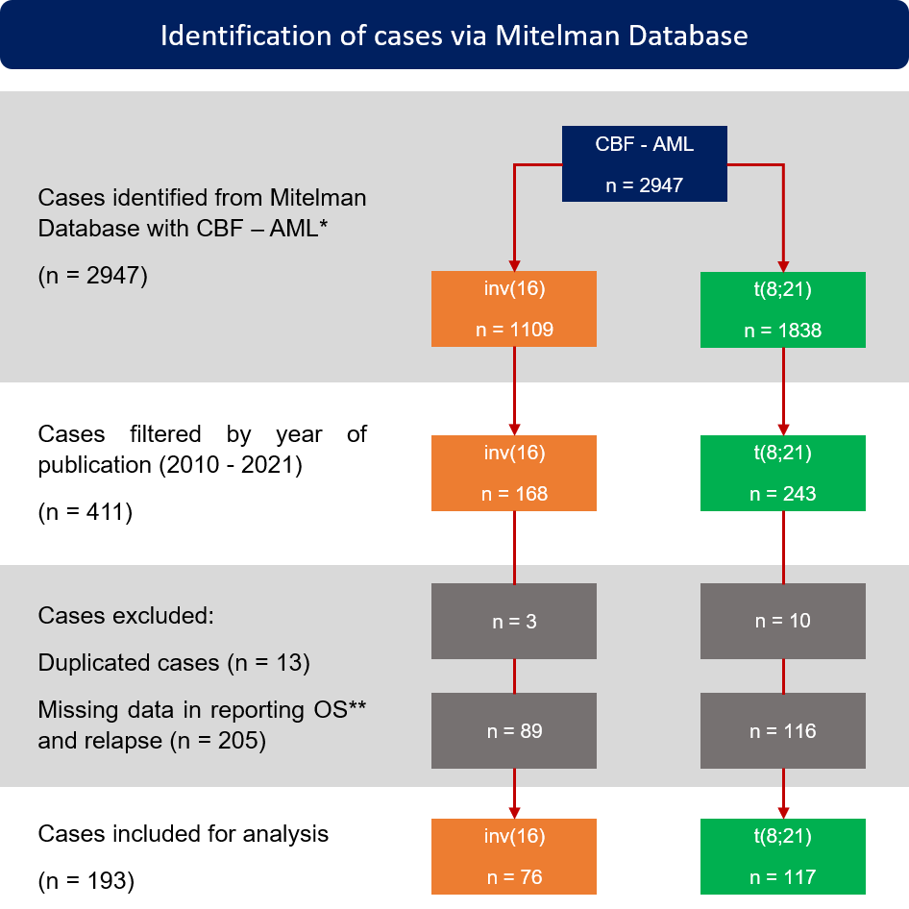
* CBF – AML: Core binding factor acute myeloid leukemia.
** Exclusion criteria: Case whose reference research presents overall survival (OS) as an average without distinguishing between each subgroup of AML – CBF or as an average in conjunction with other diseases rather than CBF - AML.
inv(16): chromosomal inversion inv(16)(p13;q22); t(8;21): chromosomal translocation t(8;21) (q22;q22)

