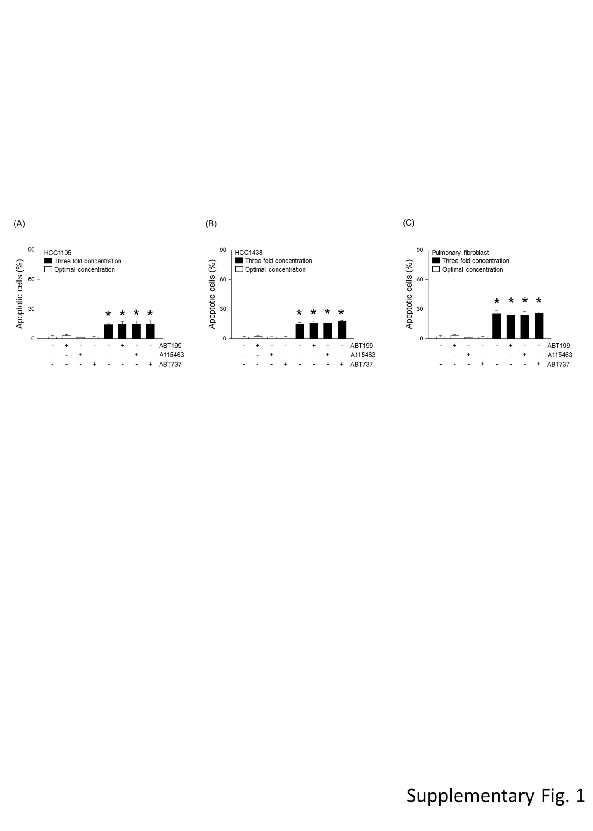
Supplementary Figure 1.
(A-C) Cell death was measured following treatment with 3 nM ABT199, 19 nM A115463, or 15 μM ABT737 for 1 h, or incubation with 9 nM ABT199, 57 nM A115463, or 45 μM ABT737 for 1 h. The Cells were fixed up to 5 h and apoptosis were determined using ELISA kit. Results are the means ± SE of 6 experiments in each group. *Significantly different from optimal concentration treatment of BH3-mimetic drugs, P < 0.05

